Redox 1. - Class worksheet
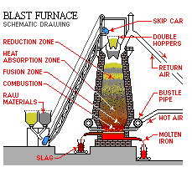

Extraction of Iron

1. What is the name and formula of the ore, found in WA, from which iron is extracted?

2. What is a blast furnace?

3. What raw materials are fed into the blast furnace
i) at the top?

ii) near the bottom?

4. a) At approximately what range of temperatures is the blast furnace maintained during the smelting of iron?

b) How is this temperature maintained?

5. a) Give the overall equation for the smelting of iron in the blast furnace.

b) What is the reducing agent used to reduce the iron(III) oxide?

c) How is this reducing produced?

6. What is the function of the limestone in the blast furnace?

7. a) What products come out of the top of the blast furnace?

b) What products come out of the bottom of the blast furnace?

8. Is the iron produced in the blast furnace very useful? Explain your answer.

9. a) How is the iron produced in the blast furnace made more useful?

b) What is the major use of iron?

c) Give examples of useful forms of iron, and their uses

Production of gold

10. In what form is gold often found naturally? Why is this?

11. a) What are the six stages in the extraction of gold by the carbon in pulp process?

b) What is the purpose of each stage? Discuss the physical and chemical features.

12. Give the ionic equation for the leaching process as well as the two component half equations.

13. How is one of the properties of gold used to advantage in the final part of the electrolysis stage?

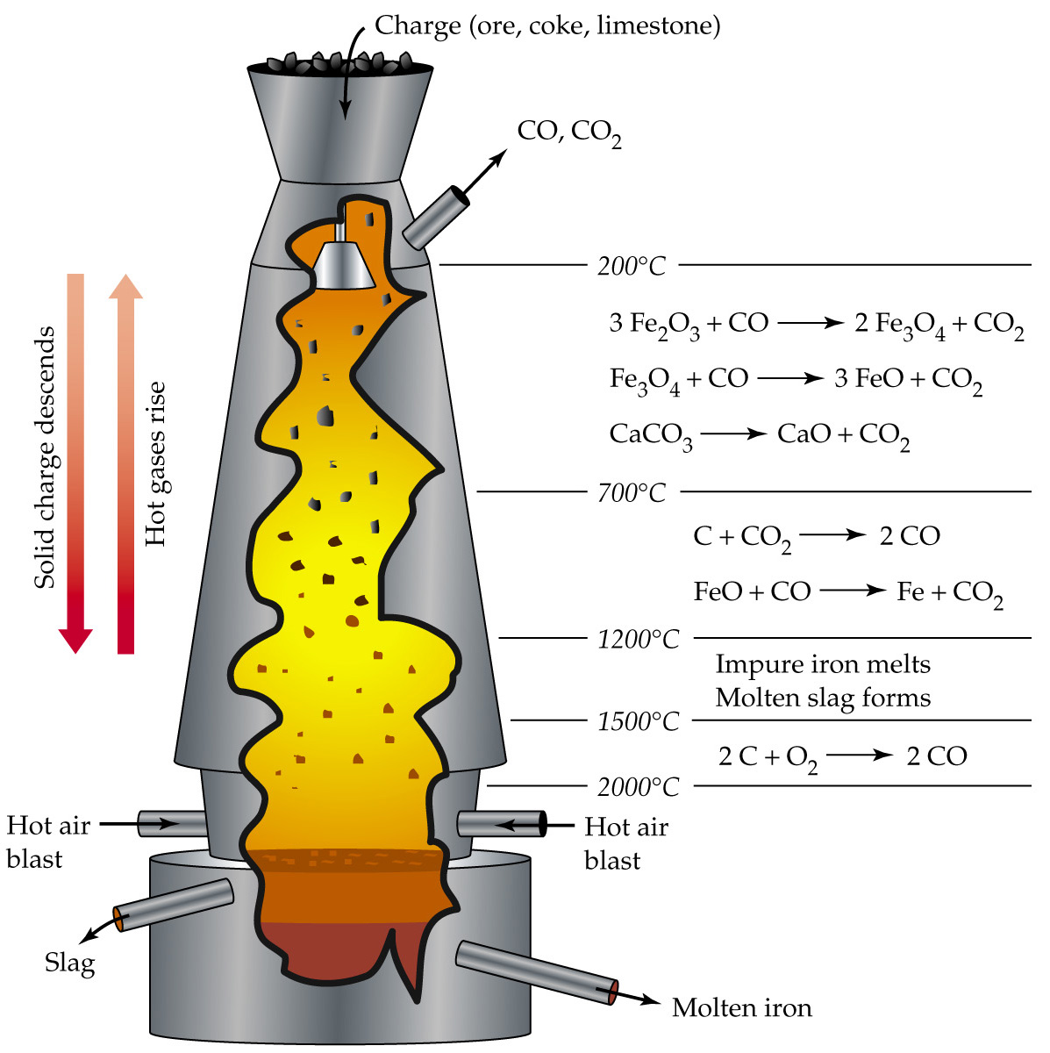

http://webpages.charter.net/kwilliams00/bcftp/docs/cyanide.htm - casual site of cyanide extraction

http://www.unige.ch/sciences/terre/mineral/fontbote/teaching/lehne_oredressing/lehne_ore_dressing_2003.pdf - has some reqadable details of CIP

The Carbon in Pulp (CIP) Process
The gold bearing ore is crushed, then finely ground to around 75 microns size, with water added to form a slurry or 'pulp'. The pulp is dosed with cyanide, and agitated through a series of tanks, in the process of leaching the gold from the ore particles and into solution. This process is termed cyanidation. On completion of cyanidation the pregnant pulp is transferred to the Carbon In Pulp (CIP) process. Figure 1 below illustrates the CIP process from the completion of cyanidation onwards.
The pregnant pulp is passed progressively through a number of tanks in series (generally around 5 or 6). These are mechanically stirred, or air agitated. Granulated carbon is passed through the tanks countercurrent to the flow of the pulp. The granulated carbon is formed from roasted coconut husks and is of a significantly larger particle size than the ground ore particles. This allows the carbon to be pumped countercurrent to the pulp through the use of screens sized to allow the finely ground ore to flow through and the coarser carbon to be contained. As the carbon passes through the tanks it collects increasing quantities of gold from solution, termed loading. The loaded carbon is seperated from the pulp in the final tank and transferred to the elution circuit. The barren pulp is dewatered, to recycle water and cyanide for reuse in the process, and the remainder, termed tailings, is transferred to the tailings dam. The tailings will contain some cyanide.
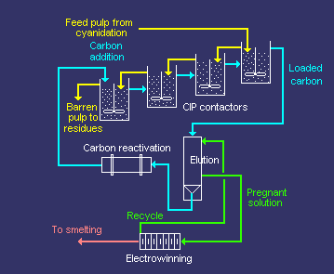
Figure 1: Carbon in Pulp (CIP) gold recovery process.
Diagram sourced from Mintek.
The loaded carbon is treated in the elution circuit with a hot cyanide and caustic solution to remove the gold from the carbon. The barren carbon is transferred to the reactivation circuit, then reused in the CIP process. The cyanide and caustic solution is passed through a electrowinning circuit where the gold is transferred to steel wool (or alternatively, it can be precipitated using zinc dust). The barren cyanide and caustic solution is recycled to the elution circuit. The gold plated steel wool is transferred to the smelting circuit to produce gold bullion, an alloy of gold, silver and other metals such as copper and iron.

http://www.marthamine.co.nz/ore_process.html

Processing Plant
At the Processing Plant, gold and silver are extracted from the ore. Ore processing consists of the following stages:
- crushing and grinding of the ore
- addition of process water (generally decanted from the tailings pond) to form a slurry
- addition of lime to the ore, and cyanide solution to the slurry, to leach the gold and silver into solution
- addition of carbon to adsorb dissolved metals and remove them from the slurry
- stripping the metals from the carbon by acid washing and circulation of a caustic cyanide solution
- precipitation of the gold and silver by electro-winning
- smelting of metal products into bars of doré bullion
- pumping of the barren slurry (tailings) to the tailings storage facility.
The Processing Plant has the capacity to treat up to 1.25 million tonnes per annum of ore.
 |  | 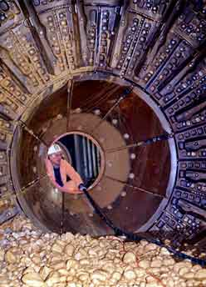 | 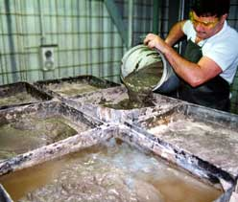 |  | 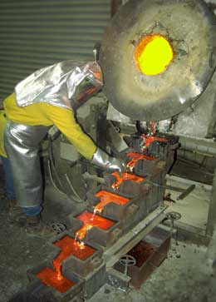
 |  | above from left: Inside the SAG Mill during a scheduled maintenance shutdown. Gold and sliver slurry is dried after electrowinning. The gold pour.
These stages can be described under three main headings:
- grinding and size classification to reduce the ore down to a fine particle size
- leaching and adsorption to extract the precious metals from the rock
- recovery of the precious metals to produce doré bullion bars.
 | 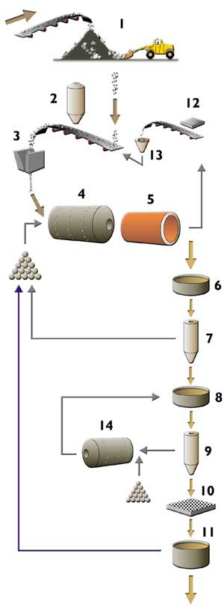 |  |  | Grinding and Sizing.  Ore processing is a 24 hour operation. Ore is stockpiled (1) at the Processing Plant, and the process begins by feeding the ore into a hopper with a loader. The ore is conveyed, and lime is added (2) to raise the pH of the ore. Following crushing through a jaw crusher (3), the ore is fed into the semi autogenous grinding (SAG) mill (4) along with water and steel balls.The grinding process reduces the rock to a slurry.  The SAG mill is a large revolving cylinder. Rock is ground by the turning action of the mill, and impact from the hardened steel balls and the rock itself. In order to ensure that the rock is ground finely enough the SAG mill has a trommel screen (5), which acts like a large sieve. The oversize rock (SCATS) is caught by the trommel, along with the worn hardened steel balls. This material is fed past a magnet (12) to separate out the steel balls. The oversize rock passes through the SCATS cone crusher (13), prior to passing once again into the SAG mill (4) for further grinding.  The slurry that is fine enough passes through the trommel to a sump (6) and then to a primary hydrocyclone (7). This hydrocyclone classifies the ground rock particles according to size – using centrifugal and gravitational forces to split the fine particles from the coarse particles. The fine particles are pumped via a sump (8) to a secondary hydrocyclone (9), and the larger particles return to the SAG mill (4) for further grinding.  The secondary hydrocyclone (9) further classifies the slurry, with the coarse particles being directed to the ball mill (14) and fine particles reporting to the trash screen (10). The ball mill is very similar to the SAG mill, except it has a larger proportion of steel balls to assist in the grinding process.  Following grinding in the ball mill, the material is returned via the sump (8) to the secondary hydrocyclone (9) for resizing. The trash screen (10) removes wood from the old workings that may have found its way into the processing circuit. The slurry that remains after this process has a very fine particle size. Typically, 80% of the ore particles are less than 70 microns in size (about the same consistency as fine beach sand). Such a fine particle size is required for gold liberation – the size required for the cyanide to be able to 'see' the gold in the leaching process.  The remaining slurry passes through a pre-leach thickener (11), to remove some of the water. The recovered water is reused in the grinding circuit while the thickened slurry moves into the leaching circuit.

 |  | 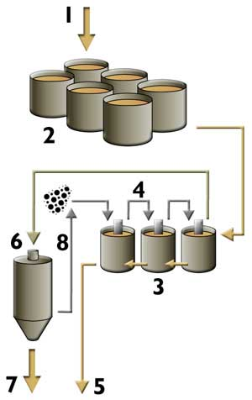 |  |  |  |  |  | Leaching and Adsorption.  The slurry (1) of ground ore and lime moves into a series of six leach tanks (2) where a sodium cyanide solution is added. The tanks provide sufficient retention time to allow the gold and silver to be dissolved by the cyanide solution. Oxygen is added to assist in this process.  The slurry then moves through a series of carbon adsorption tanks (3). While the leaching process continues in these tanks, the primary objective is to remove the gold and silver from the solution. To achieve this, carbon is fed through the tanks (4) and the gold and silver adsorbs (attaches) to the carbon granules. Carbon is heated to 600 degrees C and fed into the circuit in the opposite direction to the slurry flow, moving from the last adsorption tank to the first. This is because the gold and silver move towards the carbon via a diffusive process. It is necessary to have 'fresh' carbon at the end of the chain, to scalp the gold and silver that has not been removed in the previous tanks.  By the time the slurry reaches the final adsorption tank, most of the precious metals have been removed. The barren slurry, now known as tailings, is pumped to the tailings storage facility (5). In contrast, by the time the carbon reaches the first adsorption tank it has recovered most of the gold and silver from solution. This 'loaded' carbon is then pumped to the elution circuit (6) where the gold and silver is washed off with superheated water. The washed solution, called pregnant eluate, is passed to the electrowinning circuit (7). The remaining barren carbon is reactivated by acid washing and kilning and returned to the adsorption tanks (8).
 | 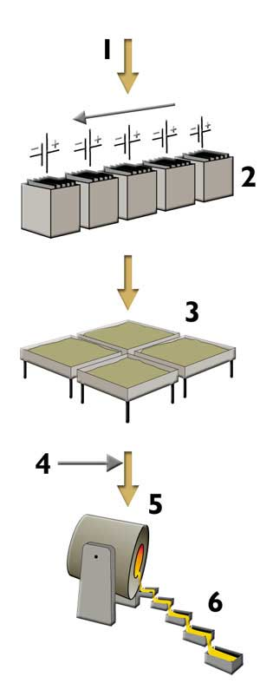 |  |  | Precious Metals Recovery.  The pregnant eluate (1) is passed through a series of electrowinning cells (2), containing cathodes in the form of stainless steel plates. The gold and silver migrates and attaches itself to the stainless steel cathodes. The cathodes are then rinsed, yielding a muddy sludge, and the cathodes are reused.The muddy sludge is dried (3), and the powder that remains is mixed with fluxes (4) and put into the furnace (5). The furnace attains a temperature of 1200 degrees C and after several hours the molten material is poured into a cascade of moulds (6) to produce doré bullion bars. The fluxes form a slag of impurities which is removed, leaving a bar which is a 99% pure melt of gold and silver. Each bar of doré bullion contains around 90% silver and 10% gold, and weighs approximately 20 kg.  The bullion is sent to the Western Australian Mint in Perth, where it is further refined to separate the gold from the silver. After refining, the gold and silver is credited to the mint accounts of each of the joint venture companies, Normandy Mining and Otter Gold. From there, each Company makes its own decisions as to the selling of the precious metals.

http://www.cyanidecode.org/library/cn_facts_use.html

Use of Cyanide in the Gold Industry
This document provides a general overview of the use of cyanide in the gold recovery process, and is not intended to be a technical reference on the use of cyanide to recover gold.

Introduction
Gold typically occurs at very low concentrations in ores - less than 10 g/t or 0.001% (mass basis). At these concentrations the use of aqueous chemical (hydrometallurgical) extraction processes is the only economically viable method of extracting the gold from the ore. Typical hydrometallurgical gold recovery involves a leaching step during which the gold is dissolved in an aqueous medium, followed by the separation of the gold bearing solution from the residues, or adsorption of the gold onto activated carbon. After elution from the activated carbon the gold is further concentrated by precipitation or electrodeposition.
Gold is one of the noble metals and as such it is not soluble in water. A complexant, such as cyanide, which stabilizes the gold species in solution, and an oxidant such as oxygen are required to dissolve gold. The amount of cyanide in solution required for dissolution may be as low as 350 mg/l or 0.035% (as 100% NaCN).
Alternative complexing agents for gold, such as chloride, bromide, thiourea, and thiosulfate form less stable complexes and thus require more aggressive conditions and oxidants to dissolve the gold. These reagents present risks to health and the environment, and are more expensive. This explains the dominance of cyanide as the primary reagent for the leaching of gold from ores since its introduction in the later part of the 19th century.

Manufacture, Transport and Storage of Cyanide
Approximately 1.4 metric tons of hydrogen cyanide are produced annually worldwide, with approximately 13% used to produce cyanide reagents for gold processing. The remaining 87% is used in industrial applications including production of plastics, adhesives, fire retardants, cosmetics, pharmaceuticals, food processing and as an anti-caking additive for table and road salts.
Cyanide is manufactured and distributed for use in gold mining industries in a variety of physical and chemical forms, including solid briquettes, flake cyanide and liquid cyanide. Sodium cyanide is supplied as either briquettes or liquid, while calcium cyanide is supplied in flake form and also in liquid form. The strength of bulk cyanide reagents vary from 98% for sodium cyanide briquettes, 44-50% for flake calcium cyanide, 28-33% for liquid sodium cyanide and 15-18% for liquid calcium cyanide. The product strength is quoted on a molar basis as either sodium or calcium cyanide.
The form of cyanide reagent chosen for use is typically dictated by availability, means of transport, distance from source and cost. Large operations close to manufacturing facilities typically prefer liquid cyanide, but due to the risk of transporting liquids over long distances and the associated cost, smaller and more remote operations use solid forms of cyanide.
Where liquid cyanide is used, it is transported to the mine by tanker truck or rail car and is off-loaded into a storage tank. The truck or rail car may have a single or double walled tank, and the location and design of the discharge equipment varies by vehicle.
Solid briquette or flake cyanide is transported to the mine in drums, plastic bags, boxes, returnable bins and ISO-containers. Depending on how the reagent is packaged, the mine will design and construct the necessary equipment to safely dissolve the solid cyanide in a high-pH solution. The pH value of cyanide solutions during dissolution must be maintained above pH 12 to avoid the volatilization of hazardous hydrogen cyanide (HCN) gas. The resulting cyanide solution is then pumped to a storage tank prior to introduction into the process.
The cyanide solution is fed from the storage tank into the metallurgical process stream in proportion to the dry mass of solids in the process stream. The feed rate of cyanide is controlled to maintain an optimum cyanide level as demanded by the metallurgy of the ore being treated.
A mine's inventory of bulk cyanide reagent is dictated by the requirements to maintain continuous operations, and to limit the frequency of off-loading events, which are regarded as safety critical events.
Although the forms of cyanide vary, once introduced into the process, the technologies used for gold recovery are the same.

Ore Preparation
Preparation of the ore is necessary so that it can be presented to the aqueous cyanide solution in a form that will ensure the optimal economic recovery of the gold. The first step in ore preparation is crushing and grinding, which reduces the particle size of the ore and liberates the gold for recovery.
Ore that contains free gold may not yield a sufficiently high recovery by sole use of cyanide leaching, due to a very long dissolution time for large gold particles. Such ore may first be subject to a gravity recovery process to recover the free gold before being subjected to cyanide leaching.
Gold bearing ores that contain gold associated with sulfide or carbonaceous minerals require additional treatment, other than size reduction, prior to gold recovery. Gold recovery from sulfide ore is poor because the cyanide preferentially leaches the sulfide minerals rather than the gold, and cyanide is consumed by the formation of thiocyanate. These ores are subject to a concentration processes such as flotation, followed by a secondary process to oxidize the sulfides, thereby limiting their interaction with the cyanide during the gold leach. Carbonaceous minerals adsorb gold once solubilized; oxidizing the ore prior to leaching prevents this. To counter this affect, the leaching process may also be modified by the addition of activated carbon to preferentially adsorb the gold.

Leaching with Aqueous Cyanide Solutions
When gold is leached in an aqueous cyanide solution it forms a gold-cyanide complex by oxidizing with an oxidant such as dissolved oxygen and cyanide complexation. This complex is very stable and the cyanide required is only slightly in excess of the stoichiometric requirement. However, in practice the amount of cyanide used in leach solutions is dictated by the presence of other cyanide consumers, and the need to increase the rate of leaching to acceptable levels.
Typical cyanide concentrations used in practice range from 300 to 500 mg/l (0.03 to 0.05% as NaCN) depending on the mineralogy of the ore. The gold is recovered by means of either heap leaching or agitated pulp leaching.
In heap or dump leaching the ore or agglomerated fine ore is stacked in heaps on a pad lined with an impermeable membrane. Cyanide solution is introduced to the heap by sprinklers or a drip irrigation system. The solution percolates through the heap leaching the gold from the ore, and the resultant gold bearing solution is collected on the impermeable membrane and channeled to storage facilities for further processing. Heap leaching is attractive due to the low capital cost involved, but is a slow process and the gold extraction efficiency is a relatively low 50-75%.
In a conventional milling and agitated leaching circuit, the ore is milled in semi-autogenous ball or rod mills until it is the consistency of powder. The milled ore (slurry) is conveyed to a series of leach tanks. The slurry is agitated in the leach tanks, either mechanically or by means of air injection, to increase the contact of cyanide and oxygen with the gold and enhance the efficiency of the leach process. The cyanide then dissolves gold from the ore and forms a stable gold-cyanide complex.
The use of oxygen or peroxygen compounds instead of air as an oxidant increases the leach rate and decreases cyanide consumption, due to the inactivation of some of the cyanide consuming species present in the slurry.
The pH of the slurry is raised to pH 10-11 using lime, at the head of the leach circuit to ensure that when cyanide is added, toxic hydrogen cyanide gas is not generated and the cyanide is kept in solution to dissolve the gold. The slurry may also be subject to other preconditioning such as pre-oxidation at the head of the circuit before cyanide is added.
Highly activated carbon is used in the dissolved gold recovery process, either by introducing it directly into the CIL (carbon-in-leach) tanks or into separate CIP (carbon-in-pulp) tanks after leaching. The activated carbon adsorbs the dissolved gold from the leach slurry thereby concentrating it onto a smaller mass of solids. The carbon is then separated from the slurry by screening and subjected to further treatment to recover the adsorbed gold.
When carbon is not used to adsorb the dissolved gold in the above-mentioned leach slurry, the gold bearing solution must be separated from the solids components utilizing filtration or thickening units. The resultant solution, referred to as pregnant solution, is subjected to further treatment (other than by carbon absorption) to recover the dissolved gold.
The waste from which the gold was removed by any means is referred to as residue or tailings material. The residue is either dewatered to recover the solution, treated to neutralize or recover cyanide, or is sent directly to the tailing storage facility.

Recovery of Dissolved Gold
Gold is recovered from the solution first using either cementation on zinc powder or concentrating the gold using adsorption on activated carbon, followed by elution and concluding with either cementation with zinc or electrowinning. For efficient cementation, a clear solution prepared by filtration or counter current decantation is required.
The most cost-effective process is to create adsorption of the dissolved gold onto activated carbon, resulting in an easier solid-solid separation based on size. To achieve this the ore particles must typically be smaller than 100 mm while the carbon particles must be larger than 500 mm. Adsorption is achieved by contacting the activated carbon with the agitated pulp. This can be done while the gold is still being leached with the CIL-process, or following leaching with the CIP-process. The CIL-process offers the advantage of countering the adsorption of gold on carbonaceous or shale ore particles, but is more expensive due to less efficient adsorption, increased gold inventory and increased fouling and abrasion of the carbon.
Activated carbon in contact with a pulp containing gold can typically recover more than 99.5% of the gold in the solution in 8 to 24 hours, depending on the reactivity of the carbon, the amount of carbon used and the mixer's efficiency. The loaded carbon is then separated from the pulp by screens that are air or hydrodynamically swept, thus preventing blinding by the near sized carbon particles. The pulp residue is then either thickened to separate the cyanide containing solution for recovery/destruction of the cyanide, or sent directly to the tailings storage facility from which the cyanide containing solution is recycled to the leach plant.
The gold adsorbed on the activated carbon is recovered from the carbon by elution, typically with a hot caustic aqueous cyanide solution. The carbon is then regenerated and returned to the adsorption circuit while the gold is recovered from the eluate using either zinc cementation or electrowinning. If it contains significant amounts of base metals, the gold concentrate is then either calcined or directly smelted and refined to gold bullion that typically contains about 70 - 90% gold. The bullion is then further refined to either 99.99% or 99.999% fineness using chlorination, smelting and electro-refining. High purity gold is taken directly from activated carbon eluates, using recently developed processes that utilize solvent extraction to produce intensive leaching of gravity concentrates.

